Assignment 1
Lyt til videoen ”How Our Criminal Justice System Targets Communities”.
Find og skriv otte ord/vendinger, som hører til det semantiske felt/skema ”prison system”.
Prison system

Assignment 2
Besvar opgave a, b, c og d med udgangspunkt i nedenstående tekststykke. Brug relevant grammatisk terminologi.
- Find og skriv fem forskellige adjektiver og fem forskellige adverbier.
Adjektiver | Adverbier

- Find og skriv to aktive og to passive sætninger.
Marker med gul overstregning verballeddet i hver af sætningerne.
Aktiv
Passiv

Omskriv de to aktive sætninger til passiv.

- Forklar anvendelsen og placeringen af apostrof i de to understregede eksempler.
Forklaring
America’s
detainees’

- Foretag en syntaktisk analyse af nedenstående sætning:
Despite this level of funding, conditions at these detention centers remain dangerous, and detainees’ rights are routinely violated.

Vær opmærksom på, at alle sætningsled ikke nødvendigvis forekommer.
Verballed
O
Subjekt
X
Subjektsprædikat
⊗
Direkte objekt
Δ
Indirekte objekt
□
Adverbialled

Konjunktional

This incisive and carefully researched article was first published by Global Research twelve years ago in March 2008.
Things have got worse since 2008. African-Americans and Latinos are routinely the victims of arbitrary arrest, incarceration and inhumane exploitation in America’s profit driven private prisons.
California has adopted legislation which bans the private prison industry from operating in the state.
“The move will probably also close down four large immigration detention facilities that can hold up to 4,500 people at a time. The legislation is being hailed as a major victory for criminal justice reform because it removes the profit motive from incarceration. It also marks a dramatic departure from California’s past, when private prisons were relied on to reduce crowding in state-run facilities. Private prison companies used to view California as one of their fastest-growing markets.” (The Guardian, September 13, 2019)
In 2018, DHS received $3 billion for custody operations. At least 75 percent of the detention facilities for which DHS contracts are privately owned or operated. Despite this level of funding, conditions at these detention centers remain dangerous, and detainees’ rights are routinely violated.

The Prison Industry in the United States: Big Business or a New Form of Slavery. Global
Research, 2021

Assignment 3
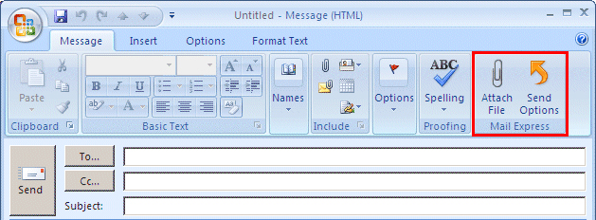

Assignment 4

